Tic Tac Toe Plan

The Rules Of The Game:

Aim Of The Game:

The aim of the game is to get your piece (either an X or an O) three is a row on the 3x3 grid.

Rules:

There are two players and they chose if they want to be either an X or an O. Then player one will go first and draw their symbol into the box they want. A tic tac toe box looks like this:

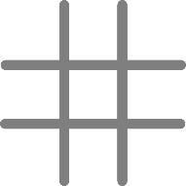

Plan:

Variables I will need to have:

* Score
* Player
* Grid

Other things I will need:

* I will need to have a 2D array that stores my grid
* Have a text file the user can see that contains how to play the game, incase they do not know

Things the user will be asked:

* What symbol do you want to be?
* Would you like to go first or seconds?
* Where would you like to place your symbol?

Testing

|  |  |  |  |
| --- | --- | --- | --- |
| Test Num | Description of Test | Test data | Expected outcome |
| 1 | Can you place an X on an O, or the other way around? |  |  |
| 2 | Can all outcomes of getting three in a row make you win? |  |  |
| 3 | Is it possible to get a draw? |  |  |
| 4 |  |  |  |